MLPEG: Using Machine Learning for Data Compression

Anthony Valencia & Jason Wiemels

2022-2023

Science Research

Abstract

Video data is the most transmitted form of data over the internet. Although streaming is quick, it can be quicker. Making streaming quicker and more efficient will allow for devices like phones, tablets, and televisions to wait less when rendering 4K images. For long term archive storage of video footage can be improved to decrease storage size and overhead cost. MLPEG aims to make video footage have a smaller footprint and is quicker than H.264 (MPEG-4), which is the most common form of video compression currently.

MLPEG uses FILM, ESPCN, Python, and an AMD Ryzen 5 3600 processor to compress video files. Videos are compressed by selecting keyframes in a video through selecting data at a certain interval, downscaling the resolution on those images, and then saving those images into a file. To decompress, MLPEG will read the compressed file, run FILM–a video interpolator–to make up the frames that were lost in the compression process, and then upscale the images to the original resolution the video was at.

Using MLPEG, file sizes became increasingly smaller at an exponential rate by a factor of two. When compared with the file sizes of MPEG-4 videos MLPEG videos were relatively equal to or less than MPEG-4. Despite some discrepancies in decompressed videos, MLPEG was also able to maintain visual quality and resolution.

MLPEG shows that machine learning models may be a viable alternative or addition to traditional forms of data compression.

**Introduction**

In the early years of computers, there was a need for saving space on a hard drive. Limited hard drive space meant that programs had to be small. Eventually, data compression became a method of reducing file sizes and saving precious hard drive space. The advent of data compression meant that there were many different algorithms going about and subsequently there was a need for standardization of data compression (Le Gall, 1991). MPEG (Moving Picture Expert Group) was founded on the basis of standardizing data compression for audio, video, and images. They created the file we are familiar with today: MPEG-3 (audio), MPEG-4 (video), and JPEG (image).

Today, data compression is used everywhere. New methods of compression have been a pivotal reason for the developments in the Internet, digital TV, mobile communication, and video communication (Pu, 2004). Since video data is the most transmitted form of data in the world and was projected to be two-thirds of traffic in 2017 (Pepper, 2013), there is a demand for smaller data sizes of videos so that video data can be transferred at a smaller, and therefore, more efficient speed on the internet.

Data compression can be broken into two different forms: lossy and lossless. Lossy compression means that the data that was compressed and decompressed is not exactly the same as the original data such as a discrepancy in a pixel's alpha value for an image. Lossless compression means that when compressed and decompressed, the resultant data is exactly the same as the input data (Pu, 2004). Video compression codecs typically come in the form of lossy because minute differences in an image are not necessarily perceived by the human eye. They rely on I, P, and B frames in a video to remove spatial and temporal redundancies in the frames of a video (Rippel et al, 2019). I-frames (“intra-coded”) are compressed using an image codec like JPEG, P-frames (“predicted”) are extrapolated from frames in the past, and B-frames (“bi-directional”) are interpolated from previously transmitted frames in the past and future (Rippel et al, 2019; Le Gall, 1991).

New machine learning model architectures in image manipulation have made it quicker and more accurate to upscale images and interpolate between frames in a video. Efficient Sub-Pixel Convolution Nueral Network (ESPCN) has made image upscaling quick and accurate. Given a 1080 HD (1920x1080 resolution) video image, ESPCN was able to outperform existing upscaling methods by more than ten times with speeds of 0.029 seconds per frame on some videos (Shi et al, 2016). For image interpolation, Google’s Frame Interpolation for Large Motion (FILM) is able to interpolate–create a new frame given two input frames–a video. FILM was able to create frames that were more accurate in terms of color (Reda et al, 2022)

These new developments in machine learning can improve video compression because of the speed and accuracy of these models. Designed for addressing the demand for smaller video sizes, MLPEG combines the power of machine learning with video compression for compression sizes that are smaller than MPEG-4 and compress/decompress times that are better or relative to MPEG-4.

**Method**

**Materials**

* Python
* Tensorflow, Numpy, OpenCV, Pandas
* YouTube
* Inter4K: A Dataset for Video Interpolation and Super-Resolution in 4K
* AMD Ryzen 5 3600 CPU

**Methods**

First, the method of compression was built. The design of the compression algorithm was created to remove a pattern of frames at a sample interval. For instance, if the sample interval was 2, every other frame of the video would be saved. The purpose of this is to remove data to reduce the file size. The compression step also includes the downscaling of images using OpenCV. The image is downscaled by a factor of 4 because the upscale algorithm we are using (ESPCN) can only upscale by a maximum of 4. Because videos are a string of images, each frame (image) is saved into a “.mlpg” file which will be read from and decoded by the compression algorithm.

The decompression component was built second. This includes reading files and normalizing data to feed to FILM and our upscale algorithms. Reading files was important at first because reading and writing image files helped with seeing how data flowed throughout the program. Especially when failed runs of programs would lose the data. Using Jupyter Notebooks also maintained context of variable values so that data flow could be addressed sequentially throughout the program without loss of data. Normalizing of data was necessary when transferring between libraries that were being used. For instance, when an image was read in from OpenCV it was in type “uint8” while the FILM tensorflow model required an image in type “float32”. Normalizing, or converting to the data type that was being used at the time, ensures that images look how they are supposed to and are not corrupted.

Lastly, was testing which included running the compress-decompress pipeline on the Inter4K video dataset. The script “test.py” first decimates the image and saves the separated images into a folder and an “.mlpg” file then takes the time for that whole process while testing at different sample intervals. Then the script decompresses the video and times how long it takes. The test calculates the ratio in size between the original image and MLPEG compressed video as well as the ratio in size between the MLPEG video and an MPEG-4 video.

**Results**

**Quantitative Results**

At the seven different sample intervals (2, 4, 8, 16, 32, 64, 128), MLPEG video sizes became increasingly smaller. For the 10 videos tested at sample interval 2, the average file size was 27.31 megabytes which is almost two times larger than the average file size of the input MPEG-4 videos. As the sample interval increased exponentially by a factor of 2, the file sizes got smaller exponentially by a factor of 2. For instance, sample interval 4 had an average file size of 13.66 MB and sample interval 8 had an average size of 6.91 MB. This also means the compression ratio between MLPEG and MPEG-4 decreased exponentially by a factor of two because the MPEG-4 video sizes remained constant.

Timing, on the other hand, was slower than MPEG-4 when compressing and decompressing. Compressing followed the trend of being an exponential decay by a factor of two while decompressing was less predictable in how long it took to decompress. MPEG-4 on average would take 30 seconds to compress a video while MLPEG would take a minute to three seconds (depending on sample interval). Where MPEG-4 encoding is nearly instantaneous, MLPEG on average took more than 20 mins to completely decompress a video.

**Qualitative Results**

As sample intervals got higher, more video data disappeared which resulted in the video looking less coherent. Additionally, for large and sudden movements, the frame interpolation cannot keep up and will misplace a group of pixels which may make edges look frayed or in worse cases misplace entire objects. During cut transitions in videos, MLPEG will interpolate the cut which adds unnecessary motion and frames to the video.

**Discussion**

The ratio of the MLPEG files to MPEG-4 files indicates that MLPEG is able to compress videos to a smaller size than MPEG-4. At the sample interval 4, MLPEG typically created files that were 1 MB to 2 MB smaller than an MPEG-4 encoded video. This means that MLPEG accomplished its goal of compressing video data smaller than MPEG-4 encoding. The trade-off trend between quality and file size was consistent with findings in image compression. The Identity Preserving Reconstruction (IPR) model lost image quality in favor of smaller compressions ratios (Xiao, 2022)

MLPEG’s time to compress is equal to MPEG-4 and its time to decompress is not as fast as MPEG-4. MPEG-4 take is instantaneous in decompressing the videos while MLPEG will take at least 20 minutes to decompress a video. This is due to the extra calculations that MLPEG must take to run. MLPEG runs two different machine learning models and runs on the Python programming language.

Given the sizes of the MLPEG files, ratio of MLPEG to MPEG-4, compress/decompress times, and visual qualities, the most optimal sample intervals to compress videos is going to be within the 4-8 range of sample intervals. The file sizes in that sample interval are small enough to be better than MPEG-4, while preserving image quality and remaining fast enough when compared to other sample intervals.

Future research includes more testing in the 4-8 sample interval range to find a better medium between file sizes, speed, and image quality. Additionally, further time spent on optimizing MLPEG to run at a faster speed such as utilizing other machine learning algorithms for image compression and using a lower level programming language will boost the speed performance of MLPEG. For more accurate testing results, different computer processors should also run MLPEG to see performance on other devices to see if a device with less resources will produce similar results.

**References**

Pu, I. (2004). Data compression. Undergraduate Study in Computing and Related Programmes. University of London.

Rippel, Oren, et al. "Learned video compression." Proceedings of the IEEE/CVF International Conference on Computer Vision. 2019.

Pepper, Robert. "Cisco visual networking index (VNI) global mobile data traffic forecast update." Technical report, Cisco, Tech. Rep. (2013).

Le Gall, Didier. "MPEG: A video compression standard for multimedia applications." Communications of the ACM 34.4 (1991): 46-58.

Shi, W., Caballero, J., Huszár, F., Totz, J., Aitken, A. P., Bishop, R., ... & Wang, Z. (2016). Real-time single image and video super-resolution using an efficient sub-pixel convolutional neural network. In Proceedings of the IEEE conference on computer vision and pattern recognition (pp. 1874-1883).

Reda, F., Kontkanen, J., Tabellion, E., Sun, D., Pantofaru, C., & Curless, B. (2022, November). Film: Frame interpolation for large motion. In Computer Vision–ECCV 2022: 17th European Conference, Tel Aviv, Israel, October 23–27, 2022, Proceedings, Part VII (pp. 250-266). Cham: Springer Nature Switzerland.

Xiao, J., Aggarwal, L., Banerjee, P., Aggarwal, M., & Medioni, G. (2022). Identity Preserving Loss for Learned Image Compression. In Proceedings of the IEEE/CVF Conference on Computer Vision and Pattern Recognition (pp. 517-526).

**Appendix**

**Figure 1.1 – MLPEG’s Compression Method**

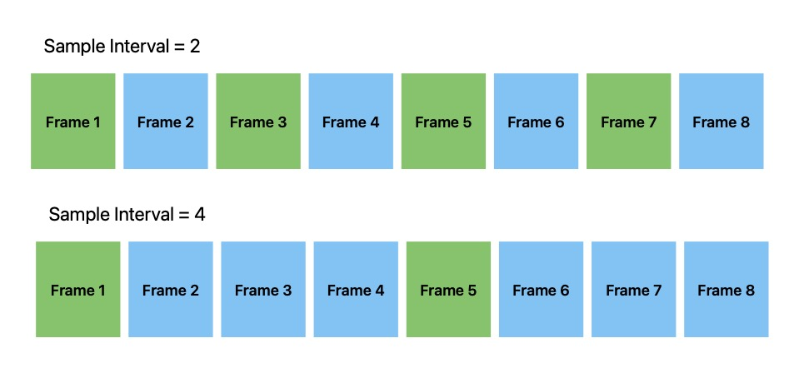

**Figure 1.2 – MLPEG’s Decompression Method**

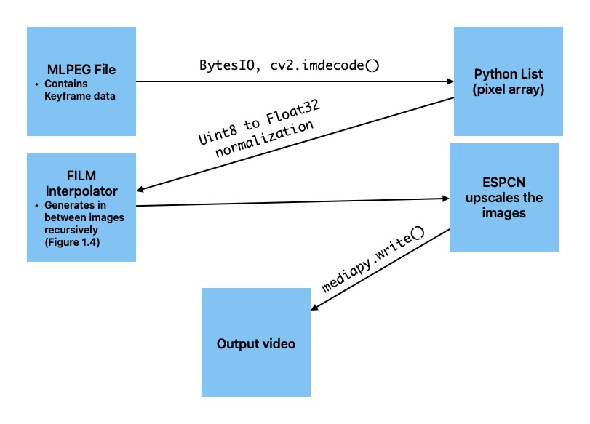

**Figure 1.3 – FILM Interpolation: Given two input images one is generated for in between**

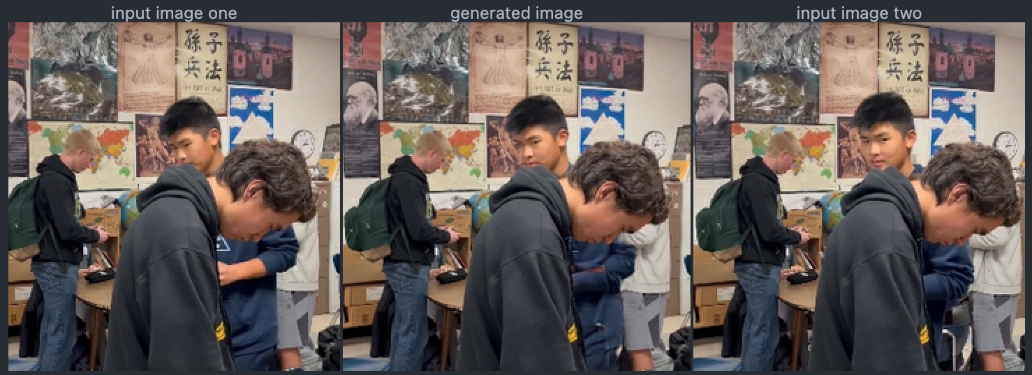

**Figure 1.4 – FILM Recursive Interpolation: Recursive representation of interpolation above. First generated then creates second generated with input images to interpolate.**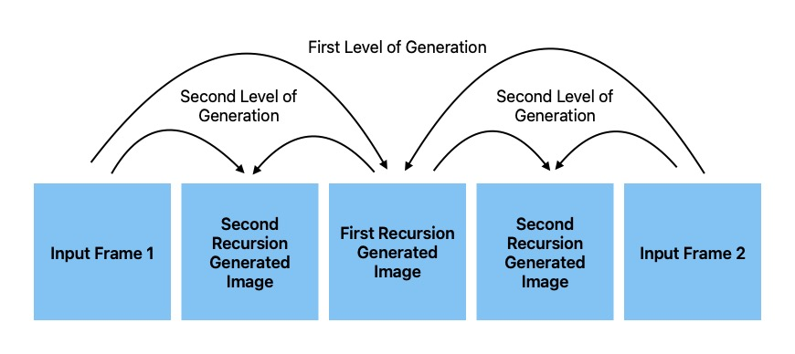

**Figure 1.5 – A super-resolution example of ESPCN; Left: low-resolution image, Middle: original Image, Right: super-resolution result, Upscaling factor: 3**

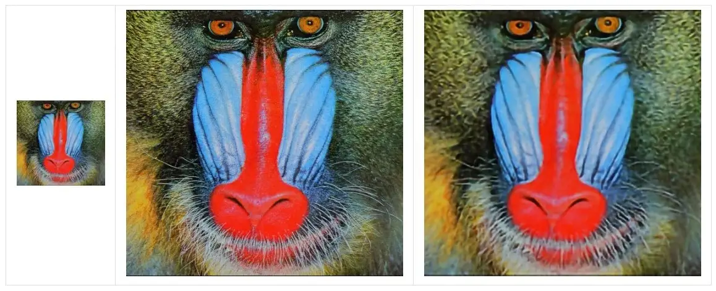

*Source: zhuo Cen, Medium*

**Figure 1.6 – Testing Suite Results**

**Sample Interval 2**

|  |  |  |  |  |  |
| --- | --- | --- | --- | --- | --- |
| Inter4K Filename | MPEG-4 sizes (Bytes) | MLPEG sizes (Bytes) | Ratio (mlpg/mp4) | Compression Time (Seconds) | Decompression Time (Seconds) |
| 1.mp4 | 11304067 | 18272736 | 1.616474495 | 52.80124235 | 1119.838737 |
| 156.mp4 | 12653142 | 22441103 | 1.773559721 | 63.27473068 | 1123.948545 |
| 2.mp4 | 25177768 | 41673450 | 1.65516856 | 86.14250231 | 1155.605619 |
| 3.mp4 | 29912201 | 38795568 | 1.296981389 | 110.6449261 | 1272.727749 |
| 4.mp4 | 21036459 | 32338075 | 1.537239466 | 112.3509462 | 1221.378205 |
| 43.mp4 | 5059672 | 14767686 | 2.918704216 | 37.42716289 | 1149.110417 |
| 5.mp4 | 14187840 | 33367193 | 2.351816274 | 101.0973794 | 1257.535869 |
| 69.mp4 | 14012037 | 21777400 | 1.554192299 | 48.54501271 | 1133.287172 |
| 7.mp4 | 13748691 | 27033195 | 1.966237731 | 72.59654951 | 1138.33119 |
| 80.mp4 | 7921244 | 22591209 | 2.851977417 | 65.39847541 | 1594.746594 |

**Sample Interval 4**

|  |  |  |  |  |  |
| --- | --- | --- | --- | --- | --- |
| Inter4K Filename | MPEG-4 sizes (Bytes) | MLPEG sizes (Bytes) | Ratio (mlpg/mp4) | Compression Time (Seconds) | Decompression Time (Seconds) |
| 1.mp4 | 11304067 | 9150861 | 0.8095193526 | 25.77977324 | 1598.692418 |
| 156.mp4 | 12653142 | 11213818 | 0.8862477004 | 30.97028399 | 1696.187432 |
| 2.mp4 | 25177768 | 20842880 | 0.8278287416 | 48.849962 | 1648.664836 |
| 3.mp4 | 29912201 | 19422324 | 0.6493110955 | 57.79728889 | 1684.817638 |
| 4.mp4 | 21036459 | 16168874 | 0.7686119608 | 44.46138644 | 1656.97424 |
| 43.mp4 | 5059672 | 7388685 | 1.460309087 | 24.48572636 | 1780.066223 |
| 5.mp4 | 14187840 | 16711523 | 1.177876477 | 60.329319 | 1667.237134 |
| 69.mp4 | 14012037 | 10891515 | 0.7772970482 | 33.7744689 | 1690.864428 |
| 7.mp4 | 13748691 | 13511330 | 0.9827357383 | 50.26615262 | 1659.083535 |
| 80.mp4 | 7921244 | 11272153 | 1.423028125 | 37.37516308 | 1611.87781 |

**Sample Interval 8**

|  |  |  |  |  |  |
| --- | --- | --- | --- | --- | --- |
| Inter4K Filename | MPEG-4 sizes (Bytes) | MLPEG sizes (Bytes) | Ratio (mlpg/mp4) | Compression Time (Seconds) | Decompression Time (Seconds) |
| 1.mp4 | 11304067 | 4638235 | 0.410315597 | 22.74543738 | 1897.045268 |
| 156.mp4 | 12653142 | 5730672 | 0.4529050571 | 21.7568047 | 1917.079088 |
| 2.mp4 | 25177768 | 10565159 | 0.4196225416 | 31.38230133 | 2090.567316 |
| 3.mp4 | 29912201 | 9810660 | 0.3279818827 | 41.53620362 | 1959.859966 |
| 4.mp4 | 21036459 | 8198864 | 0.3897454415 | 46.88282108 | 1968.989771 |
| 43.mp4 | 5059672 | 3733430 | 0.7378798468 | 23.56463861 | 1924.099245 |
| 5.mp4 | 14187840 | 8469598 | 0.5969617644 | 30.57977748 | 1967.750871 |
| 69.mp4 | 14012037 | 5489792 | 0.3917911436 | 18.3438015 | 2810.727045 |
| 7.mp4 | 13748691 | 6840509 | 0.4975389293 | 34.23227477 | 1951.566646 |
| 80.mp4 | 7921244 | 5657757 | 0.7142510697 | 27.92808318 | 1831.836093 |

**Sample Interval 16**

|  |  |  |  |  |  |
| --- | --- | --- | --- | --- | --- |
| Inter4K Filename | MPEG-4 sizes (Bytes) | MLPEG sizes (Bytes) | Ratio (mlpg/mp4) | Compression Time (Seconds) | Decompression Time (Seconds) |
| 1.mp4 | 11304067 | 2349266 | 0.2078248475 | 16.78882337 | 1949.856193 |
| 156.mp4 | 12653142 | 2935573 | 0.2320034818 | 12.74310851 | 2085.505846 |
| 2.mp4 | 25177768 | 5280906 | 0.2097448034 | 23.98728704 | 2534.698445 |
| 3.mp4 | 29912201 | 4911380 | 0.1641932 | 38.04984879 | 2008.721777 |
| 4.mp4 | 21036459 | 4116854 | 0.1957009019 | 22.74711227 | 2083.414353 |
| 43.mp4 | 5059672 | 1867039 | 0.3690039591 | 13.61734343 | 2041.406591 |
| 5.mp4 | 14187840 | 4234807 | 0.2984814461 | 24.46915412 | 1960.752388 |
| 69.mp4 | 14012037 | 2709353 | 0.193358967 | 6.895041227 | 2159.43291 |
| 7.mp4 | 13748691 | 3415440 | 0.2484192859 | 19.52371645 | 1957.030949 |
| 80.mp4 | 7921244 | 2926664 | 0.3694702499 | 10.45878935 | 1957.521864 |

**Sample Interval 32**

|  |  |  |  |  |  |
| --- | --- | --- | --- | --- | --- |
| Inter4K Filename | MPEG-4 sizes (Bytes) | MLPEG sizes (Bytes) | Ratio (mlpg/mp4) | Compression Time (Seconds) | Decompression Time (Seconds) |
| 1.mp4 | 11304067 | 1250116 | 0.1105899319 | 7.785771847 | 2018.354043 |
| 156.mp4 | 12653142 | 1529141 | 0.1208506946 | 10.89265275 | 2007.187786 |
| 2.mp4 | 25177768 | 2780733 | 0.1104439838 | 12.24899817 | 2056.050641 |
| 3.mp4 | 29912201 | 2586144 | 0.08645783037 | 11.9379797 | 2083.63454 |
| 4.mp4 | 21036459 | 2168422 | 0.1030792302 | 11.46385217 | 2129.408181 |
| 43.mp4 | 5059672 | 1013204 | 0.2002509254 | 8.674286842 | 2122.677311 |
| 5.mp4 | 14187840 | 2236118 | 0.1576080644 | 16.32043123 | 2121.079389 |
| 69.mp4 | 14012037 | 1489518 | 0.1063027453 | 13.17772675 | 2129.188908 |
| 7.mp4 | 13748691 | 1800111 | 0.1309296281 | 35.438236 | 2051.507511 |
| 80.mp4 | 7921244 | 1559738 | 0.196905688 | 22.44906282 | 2030.195457 |

**Sample Interval 64**

|  |  |  |  |  |  |
| --- | --- | --- | --- | --- | --- |
| Inter4K Filename | MPEG-4 sizes (Bytes) | MLPEG sizes (Bytes) | Ratio (mlpg/mp4) | Compression Time (Seconds) | Decompression Time (Seconds) |
| 1.mp4 | 11304067 | 656228 | 0.05805238062 | 5.803548813 | 1830.179873 |
| 156.mp4 | 12653142 | 835009 | 0.06599222549 | 8.897085667 | 1813.932294 |
| 2.mp4 | 25177768 | 1396344 | 0.05545940371 | 6.280879259 | 1798.154296 |
| 3.mp4 | 29912201 | 1331258 | 0.044505518 | 4.361325979 | 1811.618325 |
| 4.mp4 | 21036459 | 1094538 | 0.05203052472 | 3.704227209 | 1846.366643 |
| 43.mp4 | 5059672 | 504035 | 0.09961811754 | 9.271451473 | 1806.855965 |
| 5.mp4 | 14187840 | 1113154 | 0.0784583136 | 6.921127319 | 1805.501269 |
| 69.mp4 | 14012037 | 807040 | 0.0575961939 | 2.312932014 | 1803.598094 |
| 7.mp4 | 13748691 | 899052 | 0.0653918253 | 5.848042727 | 1812.851403 |
| 80.mp4 | 7921244 | 801255 | 0.1011526725 | 5.174343348 | 1801.65989 |

**Sample Interval 128**

|  |  |  |  |  |  |
| --- | --- | --- | --- | --- | --- |
| Inter4K Filename | MPEG-4 sizes (Bytes) | MLPEG sizes (Bytes) | Ratio (mlpg/mp4) | Compression Time (Seconds) | Decompression Time (Seconds) |
| 1.mp4 | 11304067 | 431512 | 0.03817316369 | 2.420104027 | 1815.231803 |
| 156.mp4 | 12653142 | 542584 | 0.04288136496 | 2.902349949 | 1836.313236 |
| 2.mp4 | 25177768 | 837842 | 0.03327705617 | 6.966519833 | 1815.334652 |
| 3.mp4 | 29912201 | 801023 | 0.02677913939 | 3.952387094 | 1831.549708 |
| 4.mp4 | 21036459 | 664554 | 0.03159058281 | 3.446572781 | 1823.731307 |
| 43.mp4 | 5059672 | 301167 | 0.05952302837 | 3.125184774 | 1856.272758 |
| 5.mp4 | 14187840 | 669816 | 0.04721056905 | 10.1213212 | 1839.162736 |
| 69.mp4 | 14012037 | 525509 | 0.03750411164 | 1.663832426 | 1814.52226 |
| 7.mp4 | 13748691 | 539495 | 0.03923973562 | 9.484451532 | 1829.337549 |
| 80.mp4 | 7921244 | 471604 | 0.05953660814 | 3.734176397 | 1817.829919 |

**Averaging for each Sample Interval**

|  |  |  |  |  |  |
| --- | --- | --- | --- | --- | --- |
| Sample Interval | MPEG-4 size (Megabytes) | MLPEG size (Megabytes) | Ratio (mlpg/mp4) | Compression Time (minutes) | Decompression Time (minutes) |
| 2 | 15.50 | 27.31 | 1.952235157 | 1.250464879 | 20.27751683 |
| 4 | 15.50 | 13.66 | 0.9762765327 | 0.6901492075 | 27.82410949 |
| 8 | 15.50 | 6.91 | 0.4938993274 | 0.4982535728 | 33.86586885 |
| 16 | 15.50 | 3.47 | 0.2488201143 | 0.3154670409 | 34.56390219 |
| 32 | 15.50 | 1.84 | 0.1323418722 | 0.2506483305 | 34.58213961 |
| 64 | 15.50 | 0.94 | 0.06782571754 | 0.09762493968 | 30.21786342 |
| 128 | 15.50 | 0.58 | 0.04157153598 | 0.07969483336 | 30.46547655 |

**Figure 1.7 – Average MLPEG File Size**

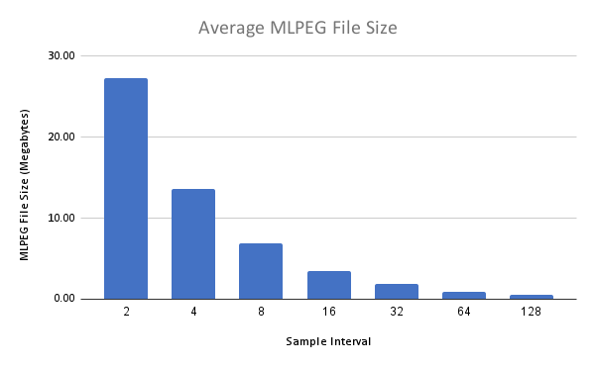

**Figure 1.8 – Average Compression Ratio**

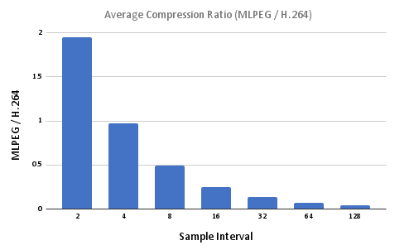

**Figure 1.9 – Compression Time**

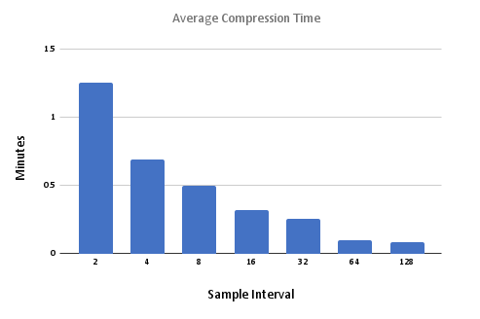

**Figure 1.10 – Decompression Time**